**Code screenshots**

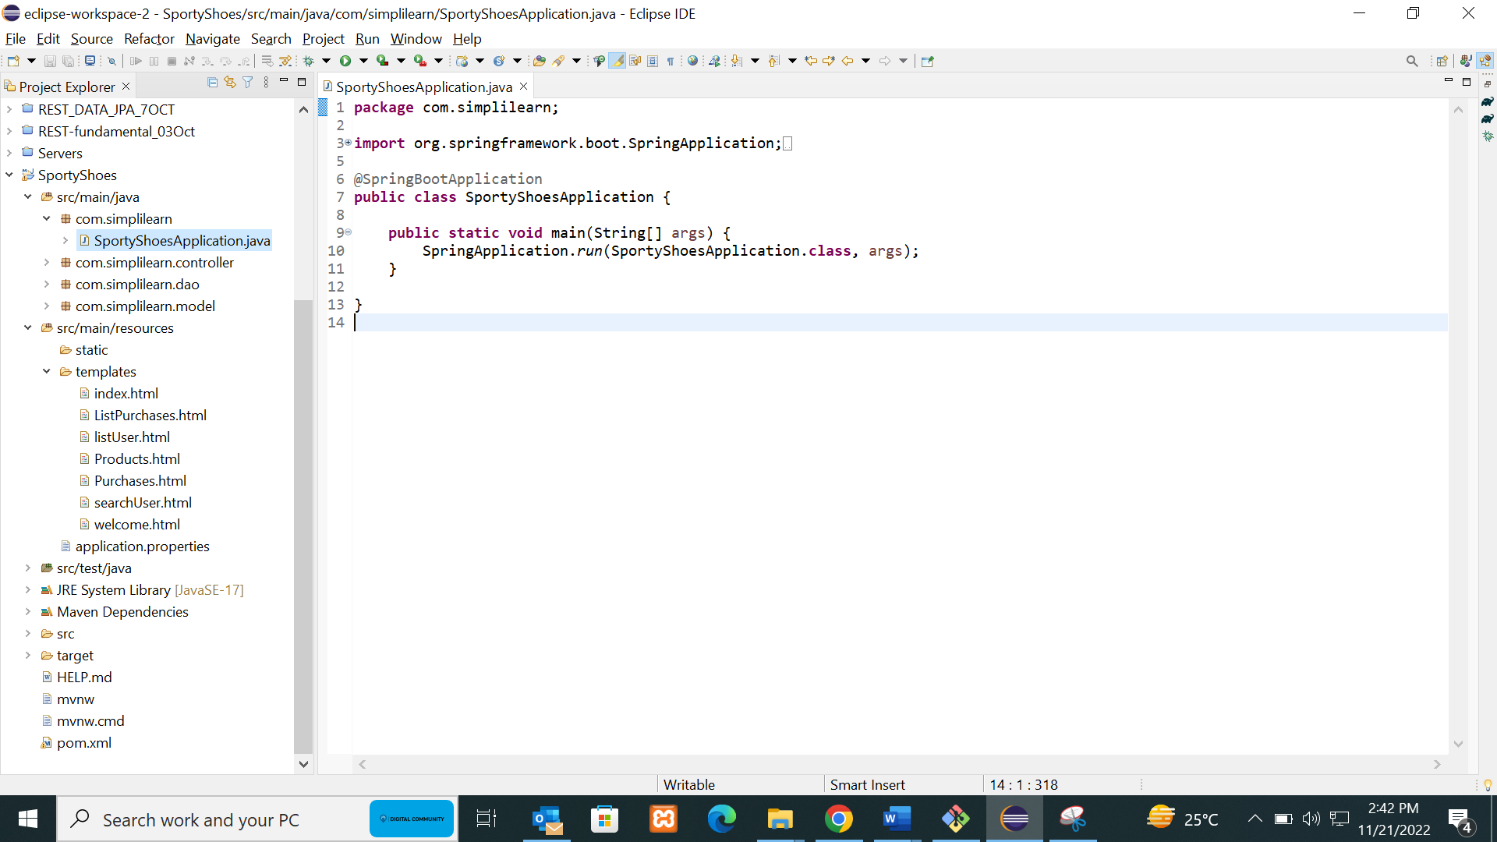

**Templates**

